



**Rio**

**A SOCIAL ROBOT WITH HUMANLY PERCEPTION**

#### **A PROJECT REPORT**

**Submitted by**

|  |  |
| --- | --- |
| **SRIVATCHAN G** | **(721418115028)** |
| **SUGAN S** | **(721418115031)** |
| **SWITHIN RAJ M DANIEL** | **(721418115033)** |

***In partial fulfilment for the award of the degree***

***of***

**BACHELOR OF ENGINEERING**

***In***

**MECHATRONICS ENGINEERING**

**NEHRU INSTITUTE OF ENGINEERING AND TECHNOLOGY**

**COIMBATORE – 641 105**

**ANNA UNIVERSITY**

**CHENNAI 600 025**

# BONAFIDE CERTIFICATE

Certified that this project report **“ RIO – A SOCIAL ROBOT WITH HUMANLY PERCEPTION ”** is the bonafide work of **“ SRIVATCHAN G, SUGAN S, SWITHIN RAJ M DANIEL ”** who carried out the project work under my supervision.

#### **SIGNATURE SIGNATURE**

**Dr. M. MAHESWARAN** **Dr. P. RAGHUNAYAGAN**

#### HEAD OF THE DEPARTMENT SUPERVISOR

Professor Assistant Professor

Department of Mechatronics Engineering Department of Mechatronics Engineering Nehru Institute of Engineering and Nehru Institute of Engineering and

Technology Technology

Coimbatore - 641 105 Coimbatore- 641 105

Submitted for the Anna University project viva-voce examination held on

……………….at Nehru Institute of Engineering and Technology.

#### **INTERNAL EXAMINER EXTERNAL EXAMINER**

Date: Date:

# DECLARATION

We affirm that the project report title “**RIO - A SOCIAL ROBOT WITH HUMANLY PERCEPTION**” being submitted in partial fulfillment of the requirements for the award of BACHELOR OF ENGINEERING in the original work carried out by us. It has not formed the part of any other project report or dissertation on basis of which degree or award was conferred on an earlier occasion on this or any other candidate.

**Date: Signature of the Candidates**

1. Srivatchan G - 721418115028
2. Sugan S - 721418115031
3. Swithin Raj M Daniel - 721418115033

I certify that the declaration made by the above candidates is true to the best of my knowledge.

Date: Name and Signature of the Supervisor

**Dr. P. Raghunayagan**

Assistant Professor

Department of Mechatronics Engineering

Nehru Institute of Engineering and Technology

Coimbatore - 641 105

**ACKNOWLEDGMENT**

At this pleasing moment of having successfully completed our project, we wish to convey our thanks and gratitude to the management of our beloved CEO and Secretary, **Dr. P. KRISHNA KUMAR** for providing all the facilities to us.

We would like to express our sincere thanks to our Principal **Dr.P.MANIIARASAN** for forwarding us to do our project and offering adequate duration to complete our project.

We are also thankful to **Dr. S.P.ARUNKUMAR,** project coordinator for his valuable suggestions during the project.

We are grateful to our Head of the Department **Dr.P.MAHESWARAN** for his constructive suggestions and encouragement during our project.

With deep sense of gratitude, we extend our earnest and sincere thanks to our guide **Dr.P.RAGHUNAYAGAN** Assistant Professor, Department of Mechatronics Engineering for his kind guidance and encouragement during this project.

We also express our in depth thanks to all the faculty members and non-teaching staffs of our department for their kind support to complete our project work.

**TABLE OF CONTENTS**

|  |  |  |
| --- | --- | --- |
| **CHAPTER NO** | **TITLE** | **PAGE NO** |
|  | **ABSTRACT** | I |
|  | **LIST OF FIGURES** | II |
|  |  |  |
|  | **LIST ABBREVIATIONS** | III |
| 1  2 | **INTRODUCTION**  **METHODOLOGY**  2.1 Overview  2.2 Progressive Process  2.3 Process Explanation | 1 |
| 3 | **LITERATURE SURVEYS**  3.1 Need of Literature Survey  3.2 Journal Reference | 6 |
| 4 | **PROBLEM IDENTIFICATION AND SOLUTION**  4.1 Problems Identified  4.2 Problems to Concentrate  4.3 Problem Solution  4.3.1 Overview  4.3.2 Solution | 8 |
| 5  6 | **HARDWARE DESCRIPTION**  5.1 Overview  5.2 IR Distance Sensor  5.2.1 Specifications  5.3 MPU6050m Sensor  5.2.1 Specifications  5.4 Grove Mouse Encoder  5.2.1 Specifications  5.5 128 x 32 LED Display  5.2.1 Specifications  5.6 Arduino Pro Mini ATMEGA 328  5.2.1 Specifications  5.7 Charging Module  5.2.1 Specifications  5.8 TTP223 Touch Button Module  5.2.1 Specifications  5.9 Li-Po Battery  5.2.1 Specifications  5.10 Buzzer  5.2.1 Specifications  5.11 Block Diagram  **SOFTWARE DESCRIPTION**  6.1 SolidWorks  6.2 Arduino IDE | 10  20 |
| 7 | **PROJECT DESCRIPTION**  7.1 Overview  7.2 Project Explanation  7.2.1 Feature 1: Follow Me  7.2.2 Feature 2: Telepresence Mode  7.2.3 Feature 3: Face Recognition  7.3 Project Design | 21 |
| 8 | **BUDGET** | 26 |
| 9 | **MERITS AND DEMERITS**  9.1 Merits  9.2 Demerits | 27 |
| 10 | **APPLICATION** | 28 |
| 11 | **FUTURE DEVELOPMENT** | 28 |
| 12 | **CONCLUSION** | 29 |
| 13 | **REFERENCES** | 30 |
| 14 | **APPENDIX** | 31 |

**ABSTRACT**

The project aims to develop a social robot named as RIO, to assist in domestic and industrial activities and also to accompany humans during their leisure. To forge a way for futuristic, autonomous robots. Capable of navigating autonomously, recognizing and synthesizing speech, and tracking faces or objects, Rio (physical assistant) is a base to build futuristic robots. Rio is a social robot that can communicate and interact with humans as we do with each other – by speaking, listening, showing emotions. Greatly defined vision gives humanly perceptions of the surroundings, helping Rio with identification and tracking objects and faces. A microphone along with noise cancellation makes it possible for Rio with speech recognition. For framing sentences with emotions on its own, Rio uses a compiler called **JULIUS GRAMMAR** compiler. Even though, there are various voice assistants such as Alexa, Siri, Cortona and Bixby are currently ruling the AI (Artificial intelligence) industry, the next evolution for AI would be giving these kinds of assistants a physical form which will later result in the creation of perfect Humanoids. Subsequently, humanoids could be built with the ability to do heavy mechanical works, which utilizes enormous human work force.

**LIST OF FIGURES**

|  |  |  |
| --- | --- | --- |
| **FIG NO.** | **LIST OF FIGURES** | **PAGE NO.** |
| 2.1 | Block diagram of Methodology |  |
| 5.2 | Raspberry Pi 3B |  |
| 5.3 | Arduino ATmega 2560 |  |
| 5.4 | Camera with Lens |  |
| 5.5 | Sound Amplifier |  |
| 5.6 | Speaker |  |
| 5.7 | Microphone |  |
| 5.8 | Ultrasonic Sensor |  |
| 5.9 | IR Sensor |  |
| 5.10 | Accelerometer and Gyroscope module |  |
| 5.11 | DC Motor |  |
| 5.12 | Battery |  |

**LIST OF ABBREVIATIONS**

|  |  |
| --- | --- |
| **TERM** | **EXPANSION** |
| AI | Artificial Intelligence |
| RAM | Random Access Memory |
| ROM | Read Only Memory |
| GHz | Giga Hertz |
| PC | Personal Computer |
| NLP | Natural Language Processing |
| LVCSR | Large Vocabulary Continuous Speech Recognition |
| HMM |  |

**CHAPTER 1**

**INTRODUCTION**

In the year 2017 the findings released by the Study of Developing Societies and Konrad Adenauer Stiftung revealed that 12 percent of the youth reported feeling depressed often and over 8 percent said they felt lonely quite frequently. Feeling lonely can also have a negative impact on your mental health, especially if these feelings have lasted a long time. Some research suggests that loneliness is associated with an increased risk of certain mental health problems, including depression, anxiety, low self-esteem, sleep problems and increased stress. It has been suggested that very advanced robotics will facilitate the enhancement of ordinary humans. This project will hope to reduce this impact of loneliness as it can act as a physical companion and it can also be used as a guide in events and gatherings. Technology continues to offer ways to [improve mental health](https://www.verywellmind.com/could-a-smartphone-app-provide-successful-treatment-for-severe-mental-illness-5210926), and a recent study found that Artificial Intelligence (AI) may detect anxiety symptoms with over 92% accuracy. These strides with technology have the potential to open up new possibilities for addressing mental health challenges more effectively. Researchers focused on specific behaviours to detect anxiety using motion sensors and deep learning techniques, including nail-biting, knuckle cracking, hand tapping, etc, which were found to be over 92% effective. These kinds of advancements could be incorporated within humanoids to accompany human-beings. Anxiety can manifest in different forms in different people which could include physical as well as emotional symptoms. This project emphasizes on the emotional well-being of a human.

**CHAPTER 2**

**METHODOLOGY**

**2.1 OVERVIEW**

To implement our project a linear step by step-by-step process is pursued as shown in the diagram below. These are the steps will be followed to attain our idea proposed to a working model and various simulation processes were done to complete the project.

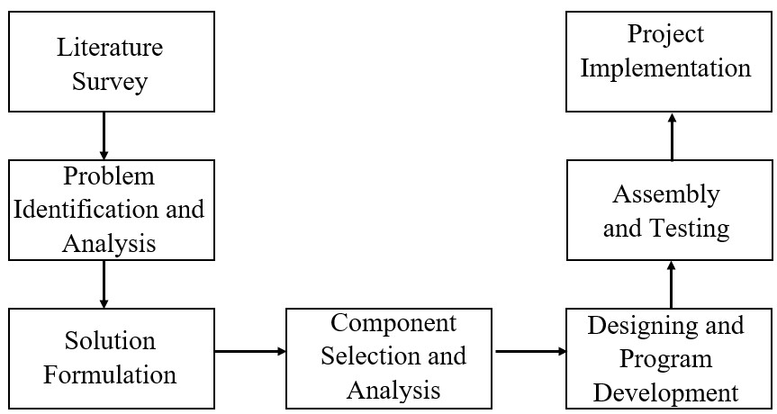

**Fig.2.1 Block Diagram of Methodology**

**2.2 PROGRESSIVE PROCESS**

The various steps involved in obtaining an efficient plan of action is listed below.

* Journal Reference
* Problem Identification
* Problem Analysis
* Solution Formulation
* Component selection and Analysis
* Designing the setup
* Testing and Analysis
* Project implementation

**2.3 PROCESS EXPLANATION**

**2.3.1 JOURNAL REFERENCE**

To improve the existing system, knowledge about existing systems is essential. Many senior authors and engineers have implemented multiple uses of the sensors which helped our idea to improve with better tools. Those proposals and ideas are studied thoroughly to attain at a possible and efficient upgrade. The existing analog systems were well studied and it is upgraded here with sensors and the working of these sensors were analyzed with many journals and research papers.

**2.3.2 PROBLEM IDENTIFICATION**

Following journal studies, identification of problems in existing systems are identified and noted. These problems when rectified should improve the performance and efficiency of the existing system to drastic level. Increment in efficiency should be seen physically; therefore, identification of problem plays a vital role.

**2.3.3 PROBLEM ANALYSIS**

The identified problems are further analyzed. Analysis involves concentration in the core cause of the problem. Cause of the problem is noted.

**2.3.4 SOLUTION FORMULATION**

When the problem is analyzed, solution for the problem is devised. With the help engineering knowledge and programming knowledge, an efficient solution is proposed for the particular problem.

**2.3.5 COMPONENT SELECTION AND ANALYSIS**

Components selection plays a major role in the implementation of solution. Specific and apt components are selected for a particular problem. Various types of simulations are done with the selected components to attain at a needed solution. Processors are chosen as per the requirements such as,

* Cache Size
* RAM
* ROM
  + - * Clock speed
      * Power efficiency
      * Processor type (32 or 64 bit)

**2.3.6 DESIGNING EXPERIMENTAL SETUP**

With conducted studies, the efficient way to proceed with experimental setup is designed with the help of designing software such as Solid-Works.

**2.3.7 TESTING AND ANALYSIS**

The designed experimental setup is tested under various required conditions. These conditions should replicate the real time conditions under which the completed product would be used.

**2.3.8 PROJECT IMPLEMENTATION**

After testing, the results are analyzed and changes are made if any unexpected conclusion occurs during the test. With the changes made the completed project is implemented. Since the project is based on AI and machine-learning, the processor required to run the instructions should be 2 GHz of clock speed. Complexity of functions and some features could be reduced due to limitations of processors.

**CHAPTER 3**

**LITERATURE SURVEY**

**3.1 NEED OF LITERATURE SURVEY**

The points needed and wanted for the proposed project has been extracted from a collection of various proposed journals by different authors. Different types of existing usage of various sensors were observed and studied. The purpose of execution of the journals was clearly shown by the authors of listed entries.

* 1. **JOURNAL REFERENCE**
     1. **Julius - An Open Source Real-Time Large Vocabulary Recognition Engine (2020)**

**Authors : Akinobu Lee, Tatsuya Kawahara, Kiyohiro Shikano**

Julius is a high-performance, two-pass LVCSR decoder for researchers and developers. Based on word 3-gram and context-dependent HMM, it can perform almost real-time decoding on most current PCs in 20k word dictation task. A two-pass, open-source large vocabulary continuous speech recognition engine Julius has been introduced. It has an ability to achieve word accuracy of 95% in accurate setting, and over 90% in real-time processing. It is well modularized with simple and popular interface to be used as an assessment platform. It provides total recognition facility with the current state of-the-art search techniques open to all researchers and developers engaging in speech-related works.

* + 1. **A Review of Recent Research in Social Robotics (2019)**

**Author: Thomas B Sheridan**

A social robot is one whose purpose is to serve a person in a caring interaction rather than to perform a mechanical task. Both because of its newness and because of its narrower psychological rather than technological emphasis, research in social robotics tends currently to be concentrated in a single journal and single annual conference. But “social robot” has generally come to have a narrower meaning, namely where the robot’s target function is not some external mechanical task, but is the human user itself. The robot’s purpose is to engage in an affective or otherwise helpful interaction directly with the person.

* + 1. **A Review of Mobile Robots: Concepts, Methods, Theoretical Framework, and Applications (2019)**

**Authors: Francisco Rubio, Francisco Valero, Carlos Llopis-Albert**

They can be distinguished from other robots by their ability to move autonomously, with enough intelligence to react and make decisions based on the perception they receive from the environment. Mobile robots must have some source of input data, some way of decoding that input, and a way of taking actions to respond to a changing world.. These new trends are led by artificial intelligence, autonomous driving, network communication, nanorobotics, friendly human–robot interfaces, safe human–robot interaction, and emotion expression and perception.

* + 1. **Voice Assistants and Smart Speakers in Everyday Life and in Education (2019)**

**Authors: George Terzopoulos, Maya Satratzemi**

An application area of AI is Natural Language Processing (NLP). Voice assistants incorporate AI by using cloud computing and can communicate with the users in natural language. The capabilities of voice assistants are continuously extending. Amazon and Google have provided platforms for developers in order to extend their assistants’ capabilities. Similar to mobile apps, Amazon Skills and Google Actions, radically expand assistants’ repertoire, allowing users to perform more actions with voice-activated control.

* + 1. **Image-Based Visual Target Following for a Nonholonomic Wheeled Mobile Robot with a Single Fixed Camera (2012)**

**Authors: Masahide Ito, Takahiro Hiratsuka, Masaaki Shibata**

We propose a control scheme composed of vision-based trajectory planning and tracking control. We present online trajectory planning based on image-based visual servoing. The key idea is to compensate the target object motion. In particular, we focus on visual feature motion resulting from the target object motion. Tracking control to the generated trajectory can therefore achieve visual target following precisely even if the target object is moving. Our proposed scheme can be applied to, e.g., robotic systems for autonomous guard and observation.

* + 1. **A Survey of Socially Interactive Robots (2003)**

**Authors: Terrence Fong, Illah Nourbakhsh, Kerstin Dautenhahn**

Social robots are embodied agents that are part of a heterogeneous group: a society of robots or humans. They are able to recognize each other and engage in social interactions, they possess histories (perceive and interpret the world in terms of their own experience), and they explicitly communicate with and learn from each other. Social robots are embodied agents that are part of a heterogeneous group: a society of robots or humans. They are able to recognize each other and engage in social interactions, they possess histories (perceive and interpret the world in terms of their own experience), and they explicitly communicate with and learn from each other. Socially interactive robots can be used for a variety of purposes: as research platforms, as toys, as educational tools, or as therapeutic aids.

**CHAPTER 4**

**PROBLEM IDENTIFICATION AND SOLUTION**

**4.1 PROBLEMS IDENTIFIED**

Nowadays, many elders have to live alone because their children have to work or have their own family. It is undeniable that many older people suffer from loneliness. A group of elderly citizens are now being lonely due to not being able to move with the young family members from place to place, as they lack physical health conditions. The children at home are in intensive need of someone to take care and monitor their activities. This tends to make them mentally affected and they are in need of some solution which can get them rid of being alone.

**4.2 PROBLEMS TO CONCENTRATE**

1. Loneliness is observed on elderly people, who long for companion.
2. Young children whose parents are absent due to work, are in drastic need of surveillance.

**4.3 PROBLEM SOLUTION**

**4.3.1 OVERVIEW**

The problems faced by children and elder people are rectified with the development of humanly robot. Role of Mechatronics plays a vital in role in providing solutions to the problems faced by all individuals. With the help Mechatronics studies, a voice assistant robot with humanly perception has been proposed.

* + 1. **SOLUTION**

We have designed a BOT which has its own Julius grammar compiler can talk on its own providing good company to people who are in need of a companion. Due to its video and audio recording capabilities, surveillance can be done effortlessly.

**CHAPTER 5**

**HARDWARE DESCRIPTION**

**5.1 OVERVIEW**

This project is designed and fabricated to a Humanly robot to interact with humans. So, it is designed with various sensors, Processor and AI technology.

**5.2 RASPBERRY PI 3B**

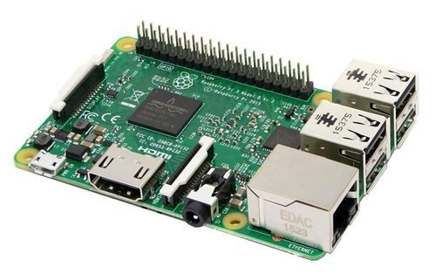

The Raspberry Pi 3 Model B is the third generation Raspberry Pi. This powerful credit-card sized single board computer can be used for many applications and supersedes the original Raspberry Pi Model B+ and Raspberry Pi 2 Model B. Whilst maintaining the popular board format the Raspberry Pi 3 Model B brings you a more powerful processer, 10x faster than the first generation Raspberry Pi. Additionally it adds wireless LAN & Bluetooth connectivity making it the ideal solution for powerful connected designs. The quad-core Raspberry Pi 3 is both faster and more capable than its predecessor, the Raspberry Pi 2. For those interested in benchmarks, the Pi 3's CPU--the board's main processor--has roughly 50-60 percent better performance in 32-bit mode than that of the Pi 2, and is 10x faster than the original single-core Raspberry Pi (based on a multi-threaded CPU benchmark in SysBench). Compared to the original Pi, real-world applications will see a performance increase of between 2.5x--for single-threaded applications--and more than 20x--when video playback is accelerated by the chip's NEON engine.

**Fig. 5.2 Raspberry Pi 3B**

**5.2.1 RASPBERRY PI 3B SPECIFICATIONS**

* Chipset : Broadcom BCM2837
* CPU : 1.2GHz quad-core 64-bit ARM cortex A53
* USB : Four USB 2.0 with 480Mbps data transfer
* Storage : MicroSD card or via USB-attached storage
* Wireless : 802.11n Wireless LAN (Peak transmit/receive throughput of 150Mbps), Bluetooth 4.1
* Graphics : 400MHz VideoCore IV multimedia
* Memory : 1GB LPDDR2-900 SDRAM
* Video : Full HDMI port
* Audio : Combined 3.5mm audio out jack and composite video

## **Raspberry Pi 2 / Raspberry Pi 3 Comparison**

|  |  |
| --- | --- |
| **Raspberry Pi 2** | **Raspberry Pi 3** |
| Processor: 32-bit quad-core ARM Cortex-A7 | Processor: 64-bit quad-core ARM Cortex-A53 |
| Clock frequency: 1000 MHz | Clock frequency: 1200 MHz |
| RAM: 1024 MB | RAM: 1024 MB |
| Wi-Fi : No | Wi-Fi : Yes |
| Bluetooth : No | Bluetooth : Yes, 4.1 |
| Network adapter: Ethernet network card | Network adapter: Ethernet network card |

**5.3 ARDUINO ATMEGA 2560**

The **Arduino Mega 2560** is a microcontroller board based on the ATmega2560. It has 54 digital input/output pins (of which 15 can be used as PWM outputs), 16 analog inputs, 4 UARTs (hardware serial ports), a 16 MHz crystal oscillator, a USB connection, a power jack, an ICSP header, and a reset button. It contains everything needed to support the microcontroller; simply connect it to a computer with a USB cable or power it with a AC-to-DC adapter or battery to get started. The Mega 2560 board is compatible with most shields designed for the Uno and the former boards Duemilanove or Diecimila.

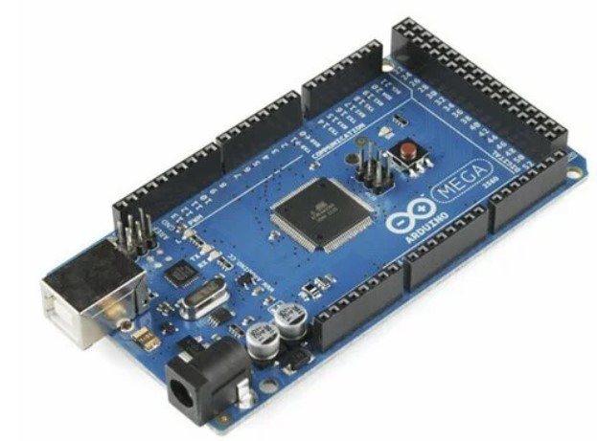

**Fig. 5.3 Arduino ATmega 2560**

**5.3.1 ARDUINO ATMEGA 2560 SPECIFICATIONS**

|  |  |  |
| --- | --- | --- |
| * Microcontroller : | | ATmega2560 |
| * Operating Voltage : | | 5V |
| * Input Voltage : | | 7-12V |
| * Digital I/O Pins : | | 54 (of which 15 provide PWM output) |
| * Analog Input Pins : | | 16 |
| * Flash Memory : | | 256 KB of which 8 KB used by bootloader |
| * Clock Speed : | 6 M Hz | |
| * Dimensions  **:** | 101.52 × 53.3 mm | |

**5.4 CAMERA WITH LENS**

It is a High resolution webcam with Clip-on design makes it easier to mount-on desktop/Laptop monitor. It has Built-in microphone and Automatic white balance.

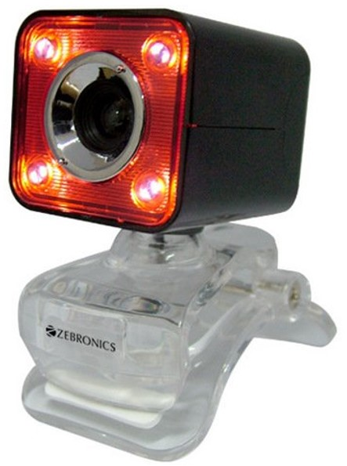

**5.4.1 CAMERA SPECIFICATIONS**

Image sensor : CMOS

Interface : USB

Lens : 3P High quality lens

**Fig. 5.4 Camera with Lens**

Video resolution : 640 x 480 (30 FPS)

Cable length : 1.3 Meter

Product dimension : 52 x 52 x  45 mm (W x D x H)

Net. Weight : 52 g

**5.5 SOUND AMPLIFIER**

This small mono amplifier is surprisingly powerful - able to deliver 3.2 Watts of power into a 4 ohm impedance speaker (5V power @ 10% THD). Inside the miniature chip is a class D controller, able to run from 2.7V-5.5VDC. There's a Gain pin that can be manipulated to change the gain. By default, the amp will give you **9dB** of gain. By connecting a pullup or pull down resistor, or wiring directly, the Gain pin can be set up to give 3dB, 6dB, 9dB, 12dB or 15dB.

**Fig. 5.5 Sound Amplifier**

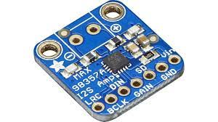

**5.5.1 SOUND AMPLIFIER SPECIFICATIONS**

* Output Power: 3.2W at 4Ω, 10% THD, 1.8W at 8Ω, 10% THD, with 5V supply
* PSRR: 77 dB typ @ 1KHz
* I2S sample rates from 8kHz to 96kHz
* No MCLK required
* Click + Pop reduction
* Five pin-selectable gains: 3dB, 6dB, 9dB, 12dB, 15dB
* Excellent click-and-pop suppression
* Thermal shutdown protection

**5.6 SPEAKER**

This sound shield was designed specifically for the Raspberry Pi and is characterised by low power consumption. It supports stereo encoding/decoding and Hi-Fi playback/recording. It can also directly control speakers to play music. Compatible with Raspberry Pi Zero/Zero W/Zero WH/2B/3B/3B+. Integrates WM8960 Low-Power Stereo CODEC, communicates via I2S interface. Integrates two high-quality MEMS silicon microphones, supporting the recording of left and right dual channels. Built-in dual-channel speaker interface that directly controls the speakers.

**Fig. 5.6 Speakers**

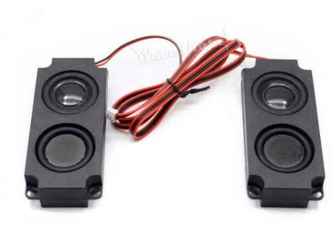

**5.6.1 SPEAKER SPECIFICATIONS**

• Power supply : 5 V  
• 3.3-V logic voltage  
• Control interface: I2C.  
• Audio interface: I2S.  
• DAC signal-to-noise ratio: 98 dB  
• ADC signal-to-noise ratio: 94 dB  
• Headphone driver: 40 mW (16 ohm @ 3.3 V)  
• Speaker driver: 1 W per channel (8-ohm BTL)

**5.7 MICROPHONE**

Raspberry Pi USB Plug and Play Desktop Microphone is  USB Microphone that offers compatibility with any plug-and-play enabled Raspberry Pi Model B+, 2 model B, Raspberry Pi 3 as wells as it is also compatible with PC and Mac,  Ideal for Chatting on Skype for video chat or useful for the recording of sound.

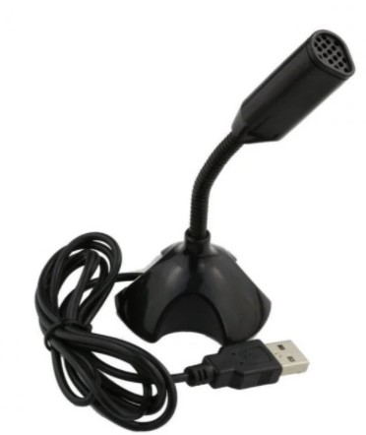

The Mic has advanced digital USB provides superior clarity with the simplicity of a single USB plug – and – play connection. Microphone pivots on base to hold a preferred position.

**Fig. 5.7 Microphone**

**5.7.1 MICROPHONE SPECIFICATIONS**

* 1.5 m long cable
* Omnidirectional response pattern
* USB 2.0 (works with Raspberry Pi)
* 50 Hz - 16 kHz frequency response
* Microphone Size (without windscreen): 6.5 cm x 0.7 cm
* 44.1 kHz/48kHz USB Sample Rate Selection
* -38 dB ± 3 dB Sensitivity’

**5.8 ULTRASONIC SENSOR**

A basic ultrasonic sensor consists of one or more ultrasonic transmitters (basically speakers), a receiver, and a control circuit. The transmitters emit a high frequency ultrasonic sound, which bounce off any nearby solid objects. Some of that ultrasonic noise is reflected and detected by the receiver on the sensor. That return signal is then processed by the control circuit to calculate the time difference between the signal being transmitted and received. This time can subsequently be used, along with some clever math, to calculate the distance between the sensor and the reflecting object.

**Fig. 5.8 Ultrasonic Sensor**

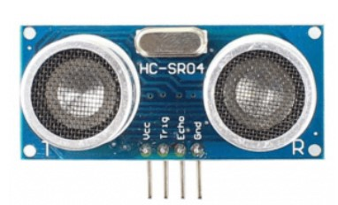

**5.8.1 ULTRASONIC SENSOR SPECIFICATIONS**

* Power Supply: DC 5V
* Working Current: 15mA
* Working Frequency: 40Hz
* Ranging Distance : 2cm – 400cm/4m
* Resolution : 0.3 cm
* Measuring Angle: 15 degree
* Trigger Input Pulse width: 10uS
* Dimension: 45mm x 20mm x 15mm

**5.9 INFRARED SENSOR**

IR technology is used in a wide range of wireless applications which includes remote controls and sensing. The wavelengths of these three regions vary based on the application. The near IR region is used on fiber optic & IR sensors, the mid-IR region is used for heat sensing and the far IR region is used in thermal imaging. The range of frequency for IR is maximum as compared to microwave and minimum than visible light.

**Fig 5.9. Infrared Sensor**

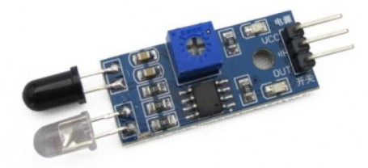

An infrared sensor includes two parts namely the emitter & the receiver (transmitter & receiver), so this is jointly called an optocoupler or a photo-coupler. Here, IR LED is used as an emitter whereas the IR photodiode is used as a receiver.

**5.8.1 INFRARED SENSOR SPECIFICATIONS**

* 5V DC Operating voltage
* I/O pins are 5V and 3.3V compliant
* Range: Up to 20cm
* Adjustable Sensing range
* Built-in Ambient Light Sensor
* 20mA supply current

**5.9 DC MOTOR WITH ENCODER**

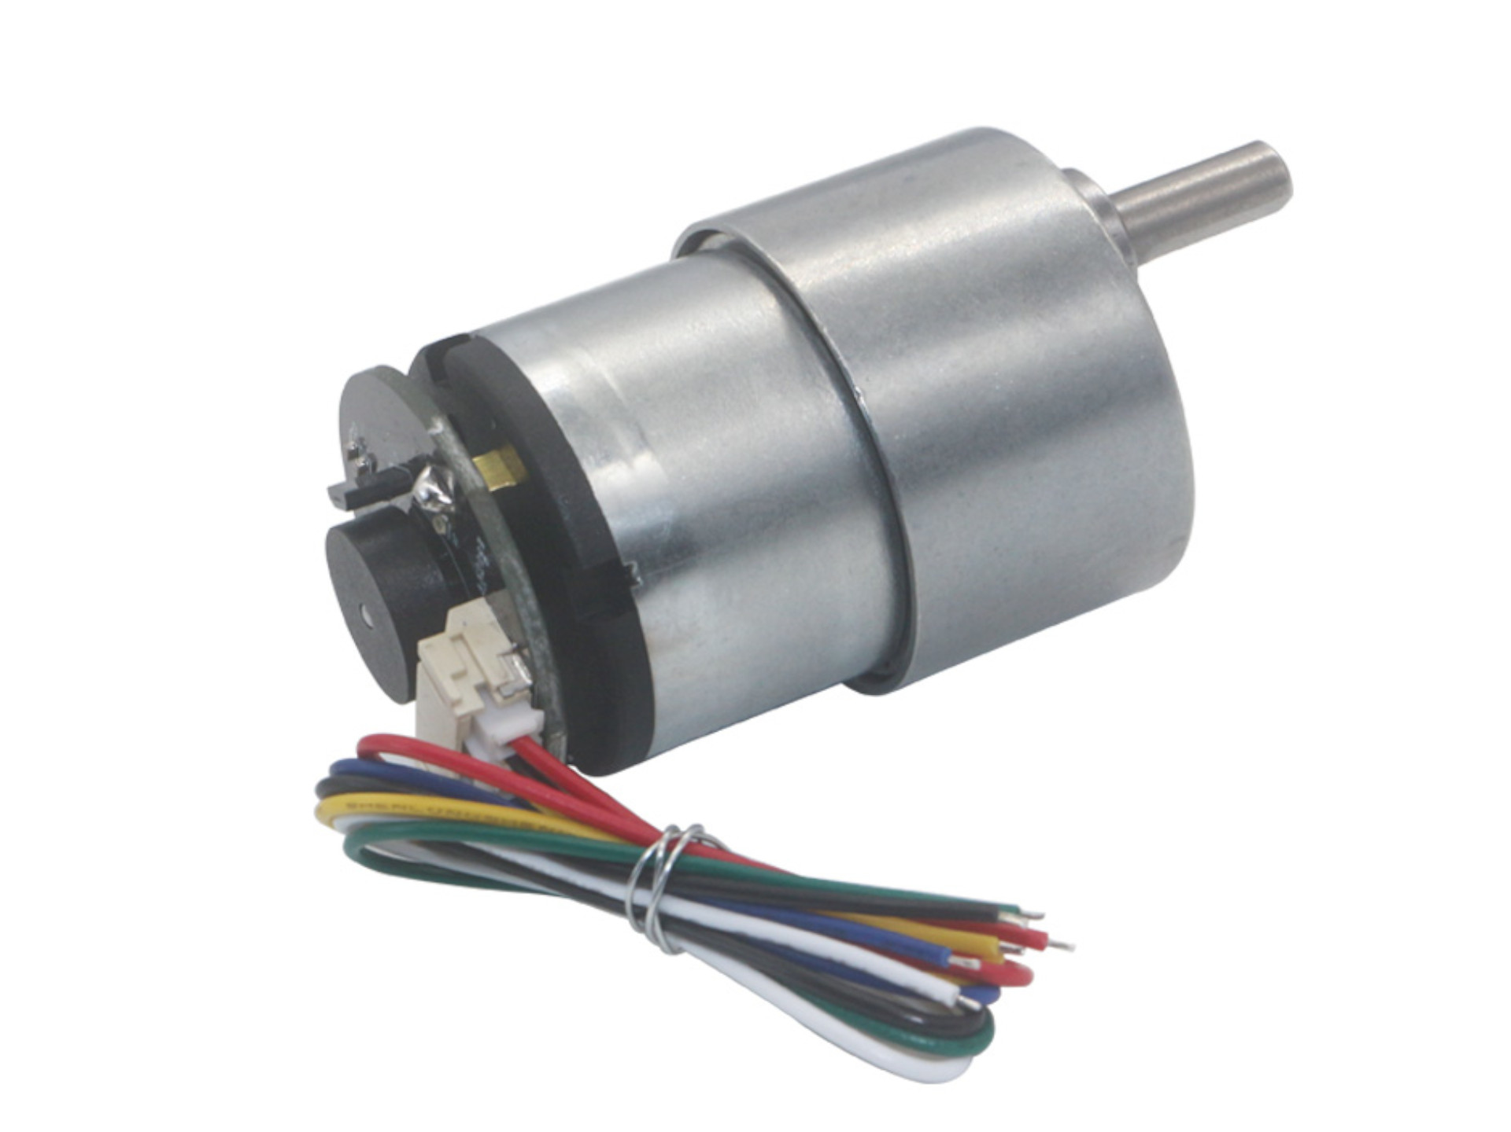

Rhino GB37 12V is a side shaft DC gear motor The compact spur gearbox has a 37mm diameter along with a D type output shaft which provides perfect coupling. The Rhino GB37 motor is available in various gear box ratios to provide an output rpm from 20 rpm to 1600 rpm suitable for different applications. There are many small machinery applications where a compact and reliable industrial motor is required and Rhino GB37 motors fit this role perfectly.

**Fig. 5.10 Rhino GB37** **Motor**

Various applications like vending machines, cofee machines, slot machines, different types of pumps, tissue dispensing machine, gaming zone machinery and many other applications. This GB37 encoder motor can help to accurately control the position of the motor. This GB37 Encoder motor is compatible with our PID Servo controller Drive.

**5.9.1 RHINO GB37** **SPECIFICATIONS :**

* Base Motor RPM: 9000
* Rated RPM: 17
* Gear ratio: 1:506.25
* Rated voltage (V): 12
* Rated current (mA): 300
* Rated power (W): 1.3
* Stall Torque (Kgcm): 20
* Shaft length (mm): 15
* Shaft diameter (mm): 6

**5.9.2 ENCODER SPECIFICATIONS:**

* Encoder Type: Quad
* PPR: 11
* CPR: 11 x 4 = 44
* CPR at output shaft: 22275

**5.10 BATTERY**

**CHAPTER 6**

**BLOCK DIAGRAM**

The project is described with a simple block diagram and the working is observed. The power supply is connected with the micro-controllers through Battery Management System (BMS) to recharge the battery. The input devices are IR sensor, Ultrasonic Sensor, Microphone, Camera, and MPU6050 module. The output is showed in the display and motion is performed by the Encoder motor based on the digital inputs from the controller.

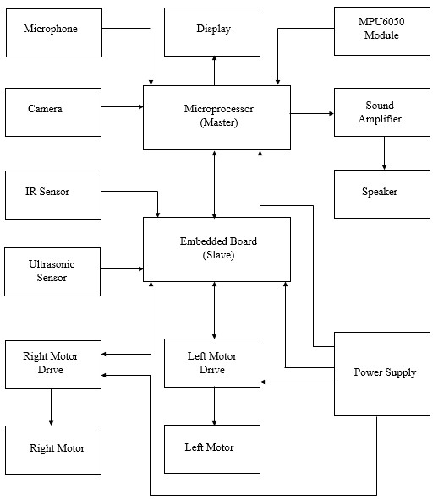

**Fig. 6.1 Block Diagram**

**CHAPTER 7**

**SOFTWARE DESCRIPTION**

**7.1 OVERVIEW**

To complete the designing and programming for the project a few software were involved.

**7.2 SOLIDWORKS**

SolidWorks is computer-aided design (CAD) software. It uses the principle of parametric design and generates three kinds of interconnected files: the part, the assembly, and the drawing. SOLIDWORKS is used to develop mechatronics systems from beginning to end. At the initial stage, the software is used for planning, visual ideation, modeling, feasibility assessment, prototyping, and project management. The software is then used for design and building of mechanical, electrical, and software elements.

**7.3 ARDUINO IDE**

The Arduino Integrated Development Environment (IDE) is a cross-platform application (for Windows, macOS, Linux) that is written in functions from C and C++. It is used to write and upload programs to Arduino compatible boards, but also, with the help of third-party cores, other vendor development boards. Arduino is an open-source electronics platform based on easy-to-use hardware and software. Arduino boards are able to read inputs - light on a sensor, a finger on a button, or a Twitter message - and turn it into an output - activating a motor, turning on an LED, publishing something online.

**7.4 PYTHON 3.9**

Python is a computer programming language often used to build websites and software, automate tasks, and conduct data analysis. Python is a general-purpose language, meaning it can be used to create a variety of different programs and isn’t specialized for any specific problems. This versatility, along with its beginner-friendliness, has made it one of the most-used programming languages today. A survey conducted by industry analyst firm RedMonk found that it was the second-most popular programming language among developers in 2021. Python is commonly used for developing websites and software, task automation, data analysis, and data visualization. Since it’s relatively easy to learn, Python has been adopted by many non-programmers such as accountants and scientists, for a variety of everyday tasks, like organizing finances.

**7.5 RASPBERRY PI – Raspbian OS**

While Raspbian is the official operating system (OS) for Raspberry Pi, there are several other OSes available, including Ubuntu, that offer some different functionality. Unlike Raspbian, Ubuntu for Raspberry Pi is available in a 64-bit version, which some apps require. For example, with 64-bit Ubuntu. The ARMv8-A architecture, which encompasses the 64-bit AArch64 architecture and associated A 64 instruction set, was first introduced into the Raspberry Pi line with Raspberry Pi 3 in 2016.

**CHAPTER 8**

**PROJECT DESCRIPTION**

**7.1 Overview**

Giving Voice assistants a physical form with certain level of movement is the main aim of this project. Voice assistants are devices/apps that use voice recognition technology, natural language processing, and AI to respond to humans. Using the technology, the device synthesizes the user’s message, breaks it down, evaluates it, and offers a meaningful response in return. There are two categories of AI voice assistants:

* General-purpose assistants
* Bot voice assistants

We are implying that giving robots autonomous speech could form the base of futuristic robots, forming a third category, Physical assistants.

**7.2 Project Explanation**

One of the key things to note when using an artificially intelligent physical assistant is to train the AI with a sufficiently large dataset of interactions with customers. Not every business might have access to well-documented support interactions that can be used as training material for the AI. In terms of facial recognition, we have developed an algorithm to train the physical assistant using live video feed. We have made use of transformers tokenizers which an nlp (natural language processing) package specially for python for the purpose of autonomous speech.

For the purpose of speech synthesis and controlling the overall functions of the physical assistant, Raspberry Pi (Micro-processor) is used and specially we have used Raspberry Pi model 3B. Respective to locomotory functions Arduino Atmega (Micro controller) is used.

**Flow of Process:**

* Since conversation is key show stopper of this project, with help of google speech recognition, human speech is recognized.
* Once the speech is recognized, it is processed and converted into text with the help of speech to text algorithm making it processable in upcoming processes.
* The program is programmed in a way to receive the converted text and look for key words such as play, recognise or hello to execute predefined functions.
* When the converted text does not contain such keywords, reply for the user’s input is generated with the help of transformers (natural language processing package) as text data.
* With text to speech module, the text data is converted into audio and transmitted through speakers.
* If key words such as “Follow” or “Telepresence” is given as the user input Arduino is switched on to control the motors for locomotion.
* Two motors are connected to the micro-controller through motor drivers, and along with the motors three sensors are connected for real time inputs to avoid and detect objects or person. The sensors are ultrasonic sensor and Infra-red sensor.

**7.2.1 Feature 1: Follow Me**

This feature includes the two wheels of the robotic setup mounted with a separate microprocessor and control unit which consist of different sensors and modules (i.e.) ultrasonic sensor, infrared sensors which helps them to move with respect to people and objects in their surroundings. The above sensors work in unison with each other and helps the robot in its operation and to navigate its path by avoiding the obstacles and maintaining a specific distance from the object.

We used ultrasonic sensor for obstacle avoidance and to maintain a specific distance from the subjected person. The ultrasonic sensor works accurately works accurately within a range of 4 meters. Ultrasonic sensors operate by calculating the times differences.

Infrared sensors detect the object’s distance with infrared radiations when the beam from transmitter detects an object it returns to the receiver with an angle after reflection also known as method of triangulation this also helps in calculation of distance travelled by robot and eliminate any further error in the robotic movement due to displacement.IR sensor controls the movement of motors and ultrasonic sensor detects the obstacle and stops the motors.

**7.2.2 Feature 2: Telepresence Mode**

Telepresence uses virtual reality technology. The telepresence robot gives a virtual reality experience that can be felt by the user even when the robot is in any remote location.

**Navigation:**

The navigation system influences the direction and movement of the robot. This circuit consists of Arduino At-Mega, ESP-8266 Wi-fi module, motor driver IC and 2 DC motors with encoder. The directional input data is received by the ESP-8266 via a smart phone. It is then computed by Arduino and then sends to the motor driver IC which drives the motors in the direction needed. These signals are transmitted by the custom build app installed on an android smart phone. First, launch the app and enter the static IP address. Data is transmitted as soon as the IP address is given as input. The Arduino then computes the commands by comparing it with the Arduino program.

**Capturing live video**:

The live video is captured with the help of the web-cam connected to the USB port of the Raspberry Pi. The live feed is then sent to the IP address through which we can see through the robot’s environment from any nook and corner of the world. Since Arduino’s and Raspberry Pi’s static IP addresses are same due to connection in the same internet router, when the Ip address is entered in the developed application, the live feed is shown in the app directly.

**7.2.3 Feature 3: Face Recognition**

We will be using a deep neural network to compute a 128-d vector (i.e., a list of 128 floating point values) that will quantify each face in the dataset. The first step is to acquire the image. Next, face detection has to be performed, to find whether the face appears in the captured image or not. The next step is to locate the position of the face in the image. Face detection and face localization is per- formed by using Haar feature-based cascade classifier. The rectangular features needed for Haar classifier are computed using an intermediate representation for the image that is called an integral image.

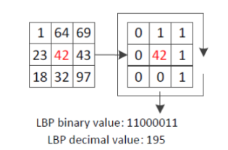

LBP example of 3x3 neighborhood, (P = 8, R = 1)

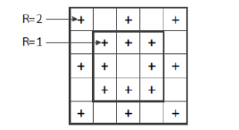

Labelling principle

The integral image at location x; y contains the sum of the pixels above and to

the left of x; y, inclusive:

i(x,y)= ∑f(x’,y’) - (1)

where i(x,y) is the integral image and f(x,y) is the original image. Using the

following pair of recurrences:

s(x,y)= s(x,y-1) + f(x,y) - (2)

i(x,y)= i(x-1,y) + f(x,y) - (3)

(where s(x, y) is the cumulative row sum, s(x,-1) = 0, and i(-1; y) = 0) the

integral image can be computed in one pass over the original image.

Using the integral image any rectangular sum can be computed by referencing four array locations. Difference between two rectangular sums can be computed in eight references. Since the two-rectangle features defined above involve adjacent rectangular sums they can be computed in six array references, eight in the case of the three- rectangle features, and nine for four-rectangle features. If the image contains a face, the algorithm returns a rectangle with coordinates where face was found. However, it is not the final region of interest (ROI) that we use. To calculate the necessary ROI, we use the coordinates of a rectangle and recalculate the ROI position. We use FERET face image database for algorithm evaluation that contains many frontal face images with their respective eye coordinates.

Raspberry Pi runs the Raspbian OS which is a Linux operating system derived from Debian. Our program is written in python programming language and uses the OpenCV library and Numpy package for image acquisition and face- detection. The developed recognition program can be used as a standalone or a part of a multimodal biometric system. When connected with another biometric system, face recognition system can work as a slave module in capture-send mode. In slave mode, system waits for the start signal, performs image acquisition and processing and then sends the acquired data to the master system.

**CHAPTER 9**

**PROJECT DESIGN**

**CHAPTER 10**

**BUDGET**

|  |  |  |  |
| --- | --- | --- | --- |
| **S.NO.** | **COMPONENT** | **QUANTITY** | **PRICE (Rs.)** |
| 1 | Raspberry Pi 3 | 1 | 6000 |
| 2 | Arduino ATmega 2560 | 1 | 750 |
| 3 | Motor Driver | 2 | 500 |
| 4 | Sound Amplifier | 1 | 700 |
| 5 | Speakers | 1 | 500 |
| 6 | Camera (with Lens) | 1 | 2500 |
| 7 | Microphone | 1 | 300 |
| 8 | DC motor | 2 | 1600 |
| 9 | Batteries (12V) with BMS | 1 | 1300 |
| 10 | Ultrasonic sensors | 2 | 300 |
| 11 | Infrared Sensor | 1 | 200 |
| 12 | Body Cost (3D printing) | - | 3000 |
| 13 | Consumables | - | 500 |
| **TOTAL** | | | **18,150** |

**CHAPTER 11**

**MERITS AND DEMERITS**

Every components have certain merits and demerits. Our project has few demerits in it and the demerits can be rectified with the advancements in Processor and sensors used.

**11.1 MERITS**

* Simple surveillance can proceed with Rio, due to its high-definition camera.
* Rio can also be used as demonstrators in museums and laboratories, where guided tours and autonomous monitoring is required.
* With a little human interaction, Rio can be used to monitor children.

**11.2 DEMERITS**

* Restricted movement due to its lower Degree of Freedom (2).
* Inability to move under extreme physical condition (i.e.) soft or very rough terrain.

**CHAPTER 12**

**APPLICATIONS**

* **Chatbots to generate leads**
* Some companies continue to use the sales department as a way to contact customers who do not know about your company, either by phone or by visiting them in person.
* Interacting with a chatbot when this person is viewing your products and services on your website is an exceptional time to grab their attention.
* **Answers to questions**
* Solve your customers' doubts to the most common questions 24/7 and at any time of the day.
* **Telepresence robot**
* It can interact with other person remotely through a mobile application.

**CHAPTER 13**

**FUTURE DEVELOPMENT**

* The processor will be updated with ITX motherboard with Intel processor for faster response and further features.
* Display will be incorporated to deliver facial expressions and to play videos.
* Some of the features have been excluded due to financial constraints, since the features require a number of sensors.
* The excluded features are:
* Cellular connection
* Bluetooth connection
* Home Automation
* Self-charging

**CHAPTER 14**

**CONCLUSION**

**CHAPTER 15**

**REFERENCES**

[1] Julius - An Open Source Real-Time Large Vocabulary Recognition Engine (2020)

Authors : Akinobu Lee, Tatsuya Kawahara, Kiyohiro Shikano

[2] A Review of Recent Research in Social Robotics (2019)

Author: Thomas B Sheridan

[3] A Review of Mobile Robots: Concepts, Methods, Theoretical Framework, and Applications (2019)

Authors: Francisco Rubio, Francisco Valero, Carlos Llopis-Albert

[4] Voice Assistants and Smart Speakers in Everyday Life and in Education (2019)

Authors: George Terzopoulos, Maya Satratzemi

[5] Image-Based Visual Target Following for a Nonholonomic Wheeled Mobile Robot with a Single Fixed Camera (2012)

Authors: Masahide Ito, Takahiro Hiratsuka, Masaaki Shibata

[6] A Survey of Socially Interactive Robots (2003)

Authors: Terrence Fong, Illah Nourbakhsh, Kerstin Dautenhahn

**CHAPTER 16**

**APPENDIX**